The modern photographs appearing on this page were taken as part of an AARP-style walkability audit of Mill Street conducted in 2020 by members of Hardwick’s Pedestrian & Traffic Safety Task Force. While the photos were taken prior to a state road repaving project, that project did not appreciably change the issues identified in the audit.

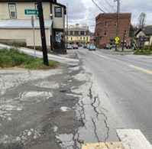
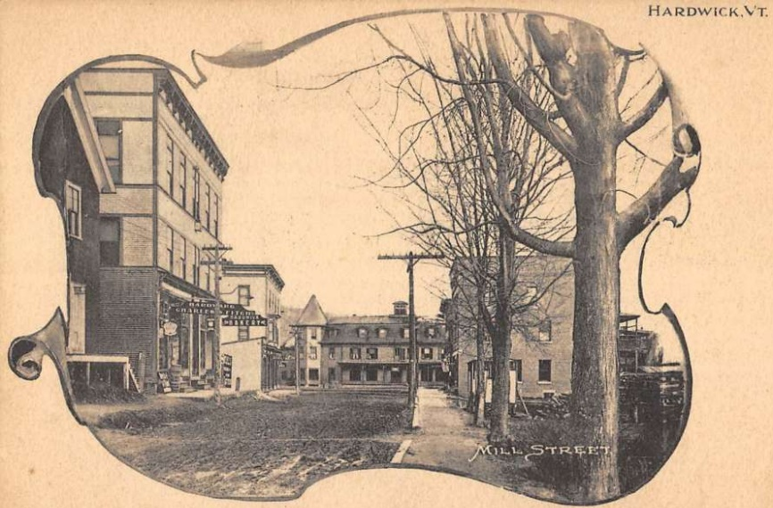

Mill Street looking northwest, brick bank
building (right), Hardwick Inn (end of street).
Today, sidewalks on the south side of Mill Street are broken and irregular and no sidewalk or trees exist on the north side of the street east of the bank building.
Historic view of Mill Street looking northwest with sidewalk and shade trees, brick bank building (right), Hardwick Inn (end of street).
While roadways have understandably evolved since the 19th century, the
Town of Hardwick hopes to rebuild some pedestrian infrastructure given up as automobiles began to dominate the transportation scene.

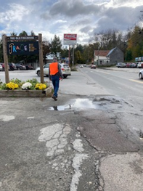

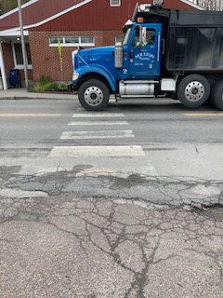

View across Mill Street to the Post Office.
This photo was taken prior to the repaving project, but the crosswalk in front of the Post Office remains non-compliant.
View of Mill Street looking southeast, Buffalo Mountain Market parking (left), public parking (right).
Sidewalks are absent from a 690-feet stretch on the northeast side of Mill Street. Two crosswalks in this stretch are non-compliant. Sharrows some limited signage are the only existing accommodations for cyclists.

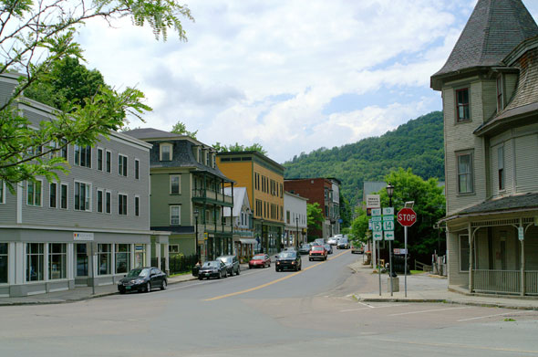

View looking southwest down South Main Street, from the intersection of South Main, North Main and Mill Streets.
This wide intersection has long been a challenge for people using all modes of transportation. Beginning in the spring of 2024, pedestrians and cyclists will be coming off the LVRT and down North Main Street into downtown Hardwick. Our scoping study project area includes this intersection and a 250-foot segment of South Main Steet from this point to the pedestrian bridge that connects South Main Street to Daniels Road.

